Pharmaceutical Innovations from Marine Resources:
A Patent-Based Assessment in the Blue Economy Era

Abstract
The oceans offer significant but underutilized potential for pharmaceutical innovation, especially when aligned with the strategic framework of the Blue Economy. This study investigates the patent landscape of marine-derived drugs approved between 1994 and 2023, with a specific focus on Spain’s innovation ecosystem. Using patent data from the Espacenet database, complemented by a corrected, evidence-based relevance classification of Spain-relevant patent families built from the Minesoft Origin database, the research maps the spatial distribution of patents, identifies leading organizations and biological sources, analyzes international patent extensions, and evaluates the quality of inventions through Patent Search Reports. Results show a high concentration of patent activity in the Community of Madrid, dominated by the private company Pharma Mar S.A., and a preference for a narrow set of marine organisms. International patenting strategies reveal a focus on high-income markets, reinforcing global asymmetries in access to marine genetic resources. Most patents rely on established prior art, signaling incremental innovation. The study offers both conceptual and empirical contributions by connecting marine biotechnology with Blue Economy principles. It provides actionable insights for policymakers seeking to decentralize innovation, promote biodiversity-based drug discovery, and strengthen benefit-sharing frameworks in marine pharmaceutical research.

Keywords: Patent analytics. Marine genetic resources. Health innovation policy. Sustainability governance. Blue economy.

1. Introduction
The United Nations Conference on Sustainable Development (Rio+20), which took place in 2012 in Rio de Janeiro, intensified debates linking climate change, sustainable economic development, and activities related to oceans, seas, and coastal resources (Howard, 2018; Morrissey, 2017; UN, 2015). Since then, recent years have witnessed an increase in interest from researchers, governments, non-governmental organizations, and civil society about the importance of promoting the sustainable use of ocean resources.
This principle called the Blue Economy or Blue Growth, is a call to rethink the way humanity and the productive sector relate to the oceans and marine resources, seeking to ensure the enjoyment of future generations while promoting more inclusive economic growth for the entire population (Voyer & Leeuwen, 2019; Winder & Le Heron, 2017). Adopting this new approach has a direct impact on various sectors of the economy and brings about profound and challenging changes. Sectors such as tourism (Cisnero-Montemayor et al., 2020; Bruno et al., 2020; Drius et al. 2019), aquaculture (Bjorkan & Eilertsen, 2020; Harper et al. 2020; Outeiro et al., 2020) or energy generation (Lavidas et al., 2020; Sheng & Lewis, 2016; Wright, 2016), for example, must undergo profound changes in their mentalities and practices.
Beyond the economic sectors, promoting the Blue Economy implies accepting challenges for stakeholders. Firstly, there is a need to increase understanding of the content and dynamics of the oceans, reducing uncertainties and increasing accuracy in decision-making. A second challenge concerns the proactive commitment of developed and developing countries to the cause (Michel, 2016). Countries should promote a series of public policies that foster research and development (R&D) in marine science and technology (Anestopoulos et al., 2020; Bilbao et al., 2020; Lee et al. 2020; Raimundo et al., 2018) or that encourage the emergence of more sustainable businesses and the change of existing practices. In addition, countries should seek to know the dynamics of their blue environment since "good data and clear metrics are critical for each country to take stock of where it stands, devise pathways for achieving the goals and track progress" (Schmidt-Traub et al., 2017, pp. 547).
If on the one hand responding to the call of the Blue Economy brings challenges for humanity, on the other it opens up numerous windows of business opportunities (Otero et al., 2019; Smith et al., 2019). Companies directly linked to the ocean economy, as well as those that extract raw materials from the ocean environment, face an additional (and probably the most challenging) problem: rethinking their current practices and aligning their future operations with a more sustainable proposal.
Given this scenario, the emergence of innovations now forms the core of the agenda for moving the Blue Economy discourse towards its practical implementation (Wang & Xiao, 2017; Upadhuau & Mishra, 2020). Sarker et al. (2018) expand on this idea by stating that, in addition to promoting innovations, it is necessary to develop a new mindset in science, technology, manufacturing, decision-making, and inter-institutional cooperation for the Blue Economy to be put into practice.
Among the opportunities promoted by the Blue Economy, the pharmaceutical industry is one of those most likely to reap the rewards of this new way of seeing the oceans as good business (Voyer et al., 2018). However, the process of creating innovative products or services can be particularly challenging for those sectors that deal with uncertainty and high R&D costs. In the pharmaceutical industry, high R&D costs can lead to results that will not always be approved by regulatory agencies, which calls for continuous monitoring of R&D productivity in biopharmaceuticals (DiMasi et al., 2016).
This study contributes to the literature on innovation and marine biotechnology by offering a novel, empirical assessment of pharmaceutical patent activity derived from marine resources, with a specific focus on Spain’s innovation ecosystem. Its originality lies in combining Blue Economy principles with patent data analysis, highlighting the geographical concentration, biological source preferences, and international patenting strategies of marine-derived drugs. By analysing Patent Search Reports and mapping legal classifications, the study provides a detailed understanding of the innovation quality and timing in this niche field—an area rarely explored in prior research. This manuscript is of interest to scholars in innovation studies, health economics, and sustainability governance, as well as to policymakers and R&D managers seeking to strengthen marine-based innovation systems in line with sustainability and equity goals. The contribution is both methodological—offering a replicable approach for other national contexts—and conceptual, by positioning marine pharmaceutical innovation as a strategic axis of the Blue Economy.

2. Literature Review

2.1. Sustainable use of ocean’s resources: towards a Blue Economy
Gradually, the notion that sustainability should also include the planet's wet environment began to gain more and more traction. It was with this in mind that, in 2012, twenty years after ECO 92, the United Nations Conference on Sustainable Development was held, also in Rio de Janeiro (Smith-Godfrey, 2016; Silver et al., 2015). Rio+20, as this new conference also came to be known, brought together 193 delegations, academics, and members of civil society, to discuss the actions being taken and propose more ambitious goals for a more sustainable world (Tollefson & Gilbert, 2012).
The concept of the Blue Economy (sometimes referred to as Blue Growth) has been gaining strength from this centrality and is understood as a mobilization of efforts to link economic development to the sustainable exploitation of marine and coastal resources, bringing well-being and quality of life to the population in line with marine environmental preservation and conservation (Keen; Schwarz; Wini-Simeon, 2017; Michel, 2016). To celebrate this importance, the United Nations (UN) declared the period from 2021 to 2030 as the Decade of Ocean Science for Sustainable Development, whose theme is "The Science we need for the Ocean we want".
Although it is a term subject to different interpretations and still with boundaries that are not fully delimited, one of the strongest associations with the Blue Economy is that linked to the ocean economy (Voyer & Lewen, 2019). Ocean economy can be understood as "that portion of the economy which relies on the ocean as an input to the production process or which, by geographic location, takes place on or under the ocean (Kildow & McIlgorm, 2010, p. 368). Five major sectors can be listed as belonging to the marine economy: extraction and use of non-living or non-renewable marine resources (e.g. mineral extraction and oil and gas extraction), use of renewable marine resources (e.g. offshore energy generation), activities in the oceans and coastal region (e.g. logistics, tourism, shipbuilding, etc.), sectors that use living marine resources (e.g. fishing, aquaculture, and the pharmaceutical industry), support activities (e.g. education, NGOs, defense, marine R&D, etc.) (Boonstra et al., 2018; Cisneros-Montemayor et al., 2021; Sarker et al., 2019; Pinto et al., 2015).
It is estimated that the maritime industry is responsible for approximately 3 to 4% of global GDP, around 2.5 trillion dollars (Vedachalam, Ravindran and Atmanand, 2019; WWF, 2015), which would be enough to position it between the eighth and seventh largest economy in the world if the industry linked to the sea were a country (Vedachalam et al., 2019). Thus, oceans, seas, and coastal resources are important sources of employment, income, innovation, and competitive advantage (OECD, 2016; Mulazzani & Malorgio, 2017).

2.2 Challenges for sustainable marine bioprospecting for pharmaceuticals
The oceans are an inexhaustible source of resources for the pharmaceutical industry. Since the late 1990s, bioprospecting (bioexploration or bioresearch), and more specifically that focused on the marine environment, has emerged as a promising area for the advancement of this industry (Rusyaaev and Orlov, 2024). Bioprospecting is understood as the discovery, development, and possible commercial supply to industry (Hunt and Vincent, 2006). Research into marine organisms such as sponges, corals, algae, molluscs, and bacteria has uncovered unique molecules that can be used in the development of new drugs. The development of new drugs from marine resources is capable of producing anti-microbial, antioxidant, anti-viral, anti-inflammatory, anti-cancer, and anti-aging agents (Anestopoulos et al., 2020). It is estimated that by 2025, the global market linked to marine biotechnology will reach the figure of U$ 6.4 billion (Blasiak et al. 2018; Vierro et al., 2016).
Despite its scientific and economic potential, technological, operational and budgetary challenges are limiting factors for the development of marine biotechnology for the pharmaceutical industry. New technologies and a dense R&D process are required for the discovery and exploitation of marine bioproducts (Smith et al., 2019). The marine bioprospecting process usually takes place in two phases. Initially, a sample is taken from each species found, and subsequently, research is carried out in an attempt to find some clue about possible advances in the focus of the research (Hunt and Vincent, 2006). To understand the basic modus operandi of marine bioprospecting for the pharmaceutical industry, we must bear in mind that tens of thousands of compounds are analyzed just to get a promising lead on some relevant active ingredient, where something like 2% reaches the market in drug form, in a process that takes an average of 14 to 15 years (Cysneros-Montemayor et al. 2019; Hunt and Vincent, 2006).
The facts raised so far lead us to realize that the costs and risks involved in the pharmaceutical industry cannot be neglected. Advances in the discovery of pharmaceutical products from the sea are still limited if we consider all the possibilities (Pereira and Costa-Lotufo, 2017). To circumvent the obstacles imposed by high R&D costs, many pharmaceutical companies prefer to invest in research already initiated by universities or public research centers, devoting more effort to products with a higher level of technological readiness (Raimundo et al., 2018). Thus, investing in innovative strategies and inter-institutional cooperation are ways to boost the sector's development (Kalogerakis et al., 2015). Increasing computational capacity and using high-throughput analytical tools to pre-screen marine microorganisms can be an alternative to reduce the costs and uncertainties of pharmaceutical R&D (Smith et al., 2019).
The consequence of these barriers in the development of new drugs from the genetic heritage present in the oceans is that only larger, more established companies can survive the high costs and risks (Cisneros-Montemayor et al., 2021; Ken, Schwarz, Wini-Simeon, 2017). As a result, marine biotechnology to produce pharmaceuticals is characterized by the dominance of a small number of countries and transnational companies. A study that investigated approximately 13,000 genetic sequences of marine origin found that 47% of patents were filed by a single company, outnumbering 220 other companies combined (37%) and universities (12%) (Blasiak et al., 2018). The same study showed that 98% of patents were filed by players located in 10 countries, which reinforces the concentration of the sector in a few countries.
Additional challenges arise when considering the sustainability bias. The process of developing an innovation linked to the sea does not always have sustainability as its objective (Keen, Schwarz and Wini-Simion, 2017). Going further, according to Cisneros-Montemayor et al. (2019), any activity that claims to be aligned with the assumption of the Blue Economy must be both socially equitable, environmentally sustainable, and economically viable.
For marine bioprospecting to become blue, the first step is to discover the real impacts of its activities, which remain poorly understood. To overcome this initial obstacle and reduce possible damage to the environment, Hunt and Vincent (2006) propose observing three criteria: i. non-selective or destructive collection methods, ii) possible introduction of pathogens or alien species by collectors, and iii) possible over-collection of target organisms. To collaborate with these criteria, R&D laboratories can cultivate and synthesize marine organisms to reduce the collection of wild organisms, minimizing the impact of extraction (Pereira and Costa-Lotufo, 2012).
The pharmaceutical industry must also deal with some critical points in the social sphere. Firstly, there is the question of who owns or should own the genetic heritage present in marine biodiversity. The United Nations Convention on the Law of the Sea (UNCLOS, 1982) defines two zones in Areas Beyond National Jurisdiction (ABNJs): the water column (high seas) and the seabed, the ocean floor and its subsoil (zone). However, around 65% of Marine Genetic Resources (MGRs) are in Areas Beyond National Jurisdiction (ABNJs), which creates a legal void that makes it difficult to regulate and share this heritage (Arnaud-Haond, Arrieta, & Duarte, 2011). Some nations advocate the creation of a common heritage for humanity, creating the necessary conditions for the emergence of a regulation capable of generating benefits for humanity and not just for a restricted group of entities (Blasiak et al., 2018). This can be particularly difficult as it is not always possible to know the geographical origin of the material collected and many species have migratory habits and/or travel long distances in the oceans (Arnaud-Haond, Arrieta, & Duarte, 2011; Hunt and Vincent, 2006). This problem would be more easily solved if bioprospecting took place on land-based species, where the area of sovereignty of countries is usually well delimited.
Finally, another stumbling block to the effective emergence of blue marine bioprospecting is linked to the fact that many developing countries have little participation in the results obtained by the pharmaceutical industry. This leads to issues such as the widening technological gap between the countries where marine resources originate and those that have the technology and resources for R&D (Arnaud-Haond, Arrieta and Duarte, 2011) or the participation of the local community in strategic issues for the Blue Economy (Contreras and Thomas, 2019).
In an attempt to minimize these impasses and make marine bioprospecting more balanced in the social, environmental, and economic spheres, some initiatives can be observed. For example, the creation of mechanisms for technology transfer and the training of qualified personnel could be an interesting counterpart to reduce the gap between technologically developed and developing countries (Cisneros-Montemayor et al., 2019). Going further, constructive cooperation between researchers, policymakers, and industry can be a rationally viable alternative to harness ocean management, innovation, and increased equity (Blasiak et al., 2018; Silva, 2024). Thus, the Nagoya Conference of the United Nations (UN) Convention on Biological Diversity (CBD) establishes protocols for the fair and equitable sharing of benefits resulting from bioprospecting (UN, 2010). Even though it is difficult to determine the geographical extent of bioprospecting and the existence of industrial property protection mechanisms, a new advance has been made by the treaty approved by the World Intellectual Property Organization (WIPO), which stipulates that research into genetic resources must indicate the country with the source of the resource and indicate which indigenous people or local community provided the traditional knowledge, where relevant (WIPO, 2024).

3. Methodology
The list of compounds was extracted from Marine Pharmacology (https://www.marinepharmacology.org/approved). In the clinical pipeline, there are Phase 1, 2, and 3, and approved Drugs. In the clinical pipeline, drugs progress through different phases of testing, namely Phase 1, Phase 2, and Phase 3. Here's an explanation of the differences between these phases:
Phase 1: This phase involves testing the drug for the first time in a small group of healthy volunteers (typically 20-100 individuals) to evaluate its safety, dosage range, and potential side effects. The main goal of Phase 1 trials is to determine the drug's safety profile and how it is metabolized and excreted by the body. These trials are usually conducted in specialized research clinics.
Phase 2: In this phase, the drug is tested in a larger group of people (typically several hundred) who have the condition the drug is intended to treat. Phase 2 trials assess the drug's effectiveness in treating the condition, as well as further evaluating its safety and side effects. These trials help researchers determine the optimal dosage and identify any common side effects associated with the drug.
Phase 3: Phase 3 trials are large-scale studies involving thousands of patients across multiple research sites. These trials further evaluate the drug's effectiveness and safety in real-world settings and provide more comprehensive data on its benefits and risks. Phase 3 trials are crucial for determining whether the drug should be approved for marketing by regulatory authorities such as the FDA (Food and Drug Administration) in the United States or the EMA (European Medicines Agency) in Europe.
Overall, the main differences between these phases lie in the size of the study population, the focus of the research objectives, and the stage of drug development. Phase 1 focuses on safety in healthy volunteers, Phase 2 evaluates efficacy and safety in a specific patient population, and Phase 3 confirms efficacy, monitors side effects, and assesses the overall risk-benefit profile in a larger and more diverse patient population.
We only selected the approved marine drugs with the last update of April 10th, 2024 (Table 1). Centering analysis on approved drugs offers several advantages.
Safety and Efficacy. Approved drugs have undergone rigorous testing through clinical trials to establish their safety and efficacy profiles. Analyzing approved drugs allows researchers to work with substances that have already demonstrated a favorable risk-benefit profile in a specific patient population.
Clinical Relevance. Approved drugs are those that have demonstrated therapeutic benefits in treating specific medical conditions. Analyzing these drugs provides insights into their mechanisms of action, therapeutic effects, and potential side effects in real-world clinical settings.
Regulatory Compliance. Regulatory agencies such as the FDA and EMA have evaluated approved drugs based on stringent criteria for safety, efficacy, and quality. Analyzing approved drugs ensures compliance with regulatory standards and guidelines, which is essential for drug development and clinical practice.
Market Demand. Approved drugs are available for prescription and use in clinical practice, making them valuable assets for pharmaceutical companies and healthcare providers. Analyzing approved drugs allows researchers to assess market demand, prescribing patterns, and patient outcomes associated with these medications.
Data Availability. Approved drugs have extensive data available from clinical trials, post-marketing surveillance, pharmacovigilance databases, and medical literature. Analyzing approved drugs provides access to a wealth of information that can inform research and decision-making in drug development, healthcare policy, and clinical practice.
Overall, centering analysis on approved drugs offers a practical and valuable approach for researchers, clinicians, and policymakers seeking to understand the safety, efficacy, and clinical utility of medications in patient care.

Table 1. List of approved drugs.
Compound Name | Marine Organism | Disease Area
Cytarabine (Ara-C) | Sponge | Cancer: Leukemia
Vidarabine (Ara-A) | Sponge | Antiviral: Herpes Simplex Virus
Ziconotide | Cone snail | Pain: Severe Chronic Pain
Omega-3-acid ethyl esters | Fish | Hypertriglyceridemia
Eicosapenta enoic acid ethyl ester | Fish | Hypertriglyceridemia
Omega-3-carboxylic acid | Fish | Hypertriglyceridemia
Eribulin Mesylate (E7389) | Sponge | Cancer: Metastatic Breast Cancer
Brentuximab vedotin (SGN-35) | Mollusk/ Cyanobacterium | Cancer: Anaplastic large T-cell systemic maglinant lymphoma, Hodgkin's disease
Trabectedin (ET-743) | Tunicate | Cancer: Soft Tissue Sarcoma and Ovarian Cancer
Plitidepsin | Tunicate | Cancer: Multiple Myeloma, Leukemia, Lymphoma
Polatuzumab vedotin (DCDS-4501A) | Mollusk/ Cyanobacterium | Cancer: Non-Hodgkin lymphoma, Chronic lymphocytic leukemia, Lymphoma, B-Cell lymphoma, Folicular
Enfortumab Vedotin-ejfv | Mollusk/ Cyanobacterium | Metastatic urothelial cancer
Lurbinectedin | Tunicate | Cancer: Metastatic Small Cell Lung Cancer
Disitamab Vedotin | Mollusk/ Cyanobacterium | Cancer: Urothelial Carcinoma, Advanced Cancer, Gastric Cancer, HER2 Overexpressing Gastric Carcinoma, Advanced Breast Cancer, Solid Tumors
Tisotumab vedotin-tftv | Mollusk/ Cyanobacterium | Metastatic cervical cancer
Source: 2021-2024 Marine Pharmacology.

After gathering the data from the Espacenet database, the data was inspected in order to guarantee its usability for the applications to generate the images. For the case of maps (Figures 1 and 2), the infogram.com application was used, while for graphs (Figures 3 and 4), the rawgraphs.io application was used. The adopted methodological procedures for data presentation were the alluvial graphs as implemented by Ferasso et al. (2021).
A corrected, evidence-based relevance classification supplements this analysis for Table 2 and Figures 7–9 (Section 4.2): every Spain-relevant patent family returned by a family-level search of the Minesoft Origin database (2000–2025) for each compound was individually screened against its full claim and description text and classified as Directly Relevant, Indirectly Relevant, Incidental Mention, or Uncertain, superseding an earlier, narrower country-code-filtered search. This corrected analysis covers 12 of the 14 approved marine-derived drugs listed in Table 1; Disitamab Vedotin and Tisotumab vedotin-tftv are not covered and are excluded from Table 2 and Figures 7–9.

4 Results

4.1 Patent mapping and analysis
Figure 1 illustrates the patent distribution per country. The top five countries in patents are ranked as follows: Spain (217 patents, 5.8% of worldwide jurisdiction mentions), the USA (208, 5.6%), Japan (189, 5.1%), Canada (184, 4.9%), and China (175, 4.7%).

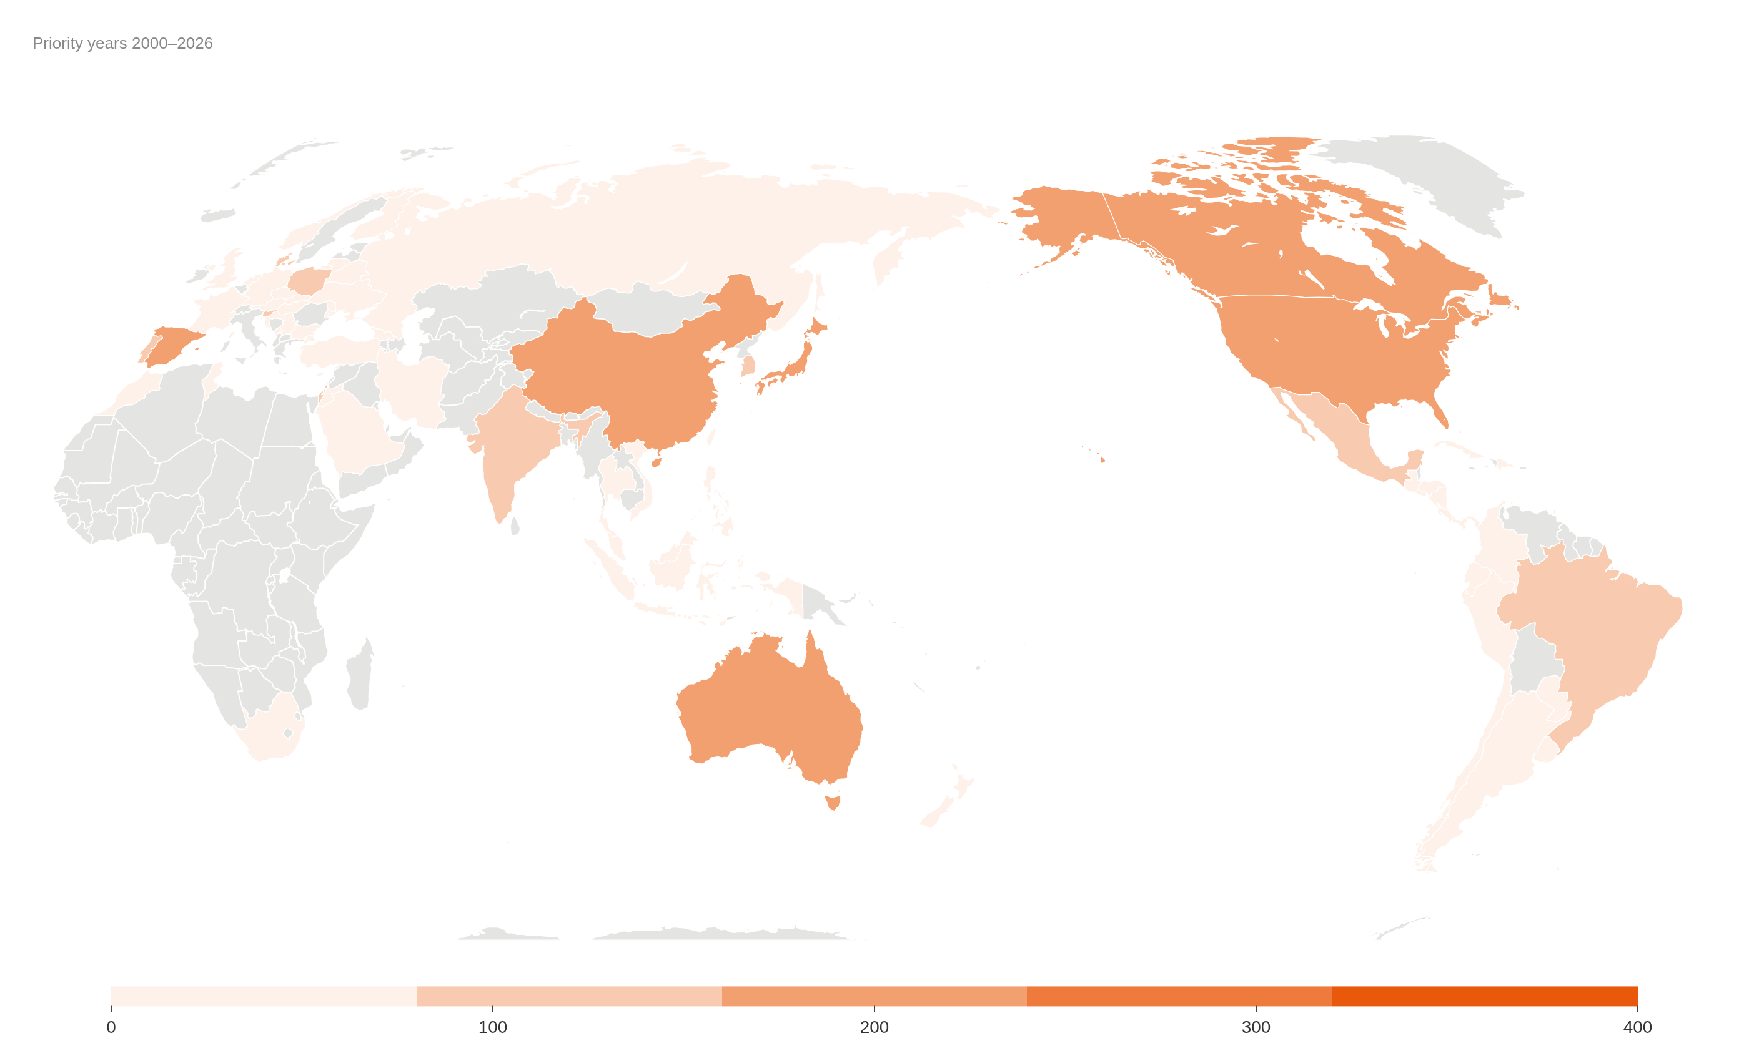
Figure 1 – World map of patent distributions.
Source: own elaboration with infogram.com application
In the European scenario, Spain leads with 217 patents, followed by Denmark (137), Poland (115), Portugal (100), and Slovenia (81). Figure 2 illustrates the European distribution of patents per country.
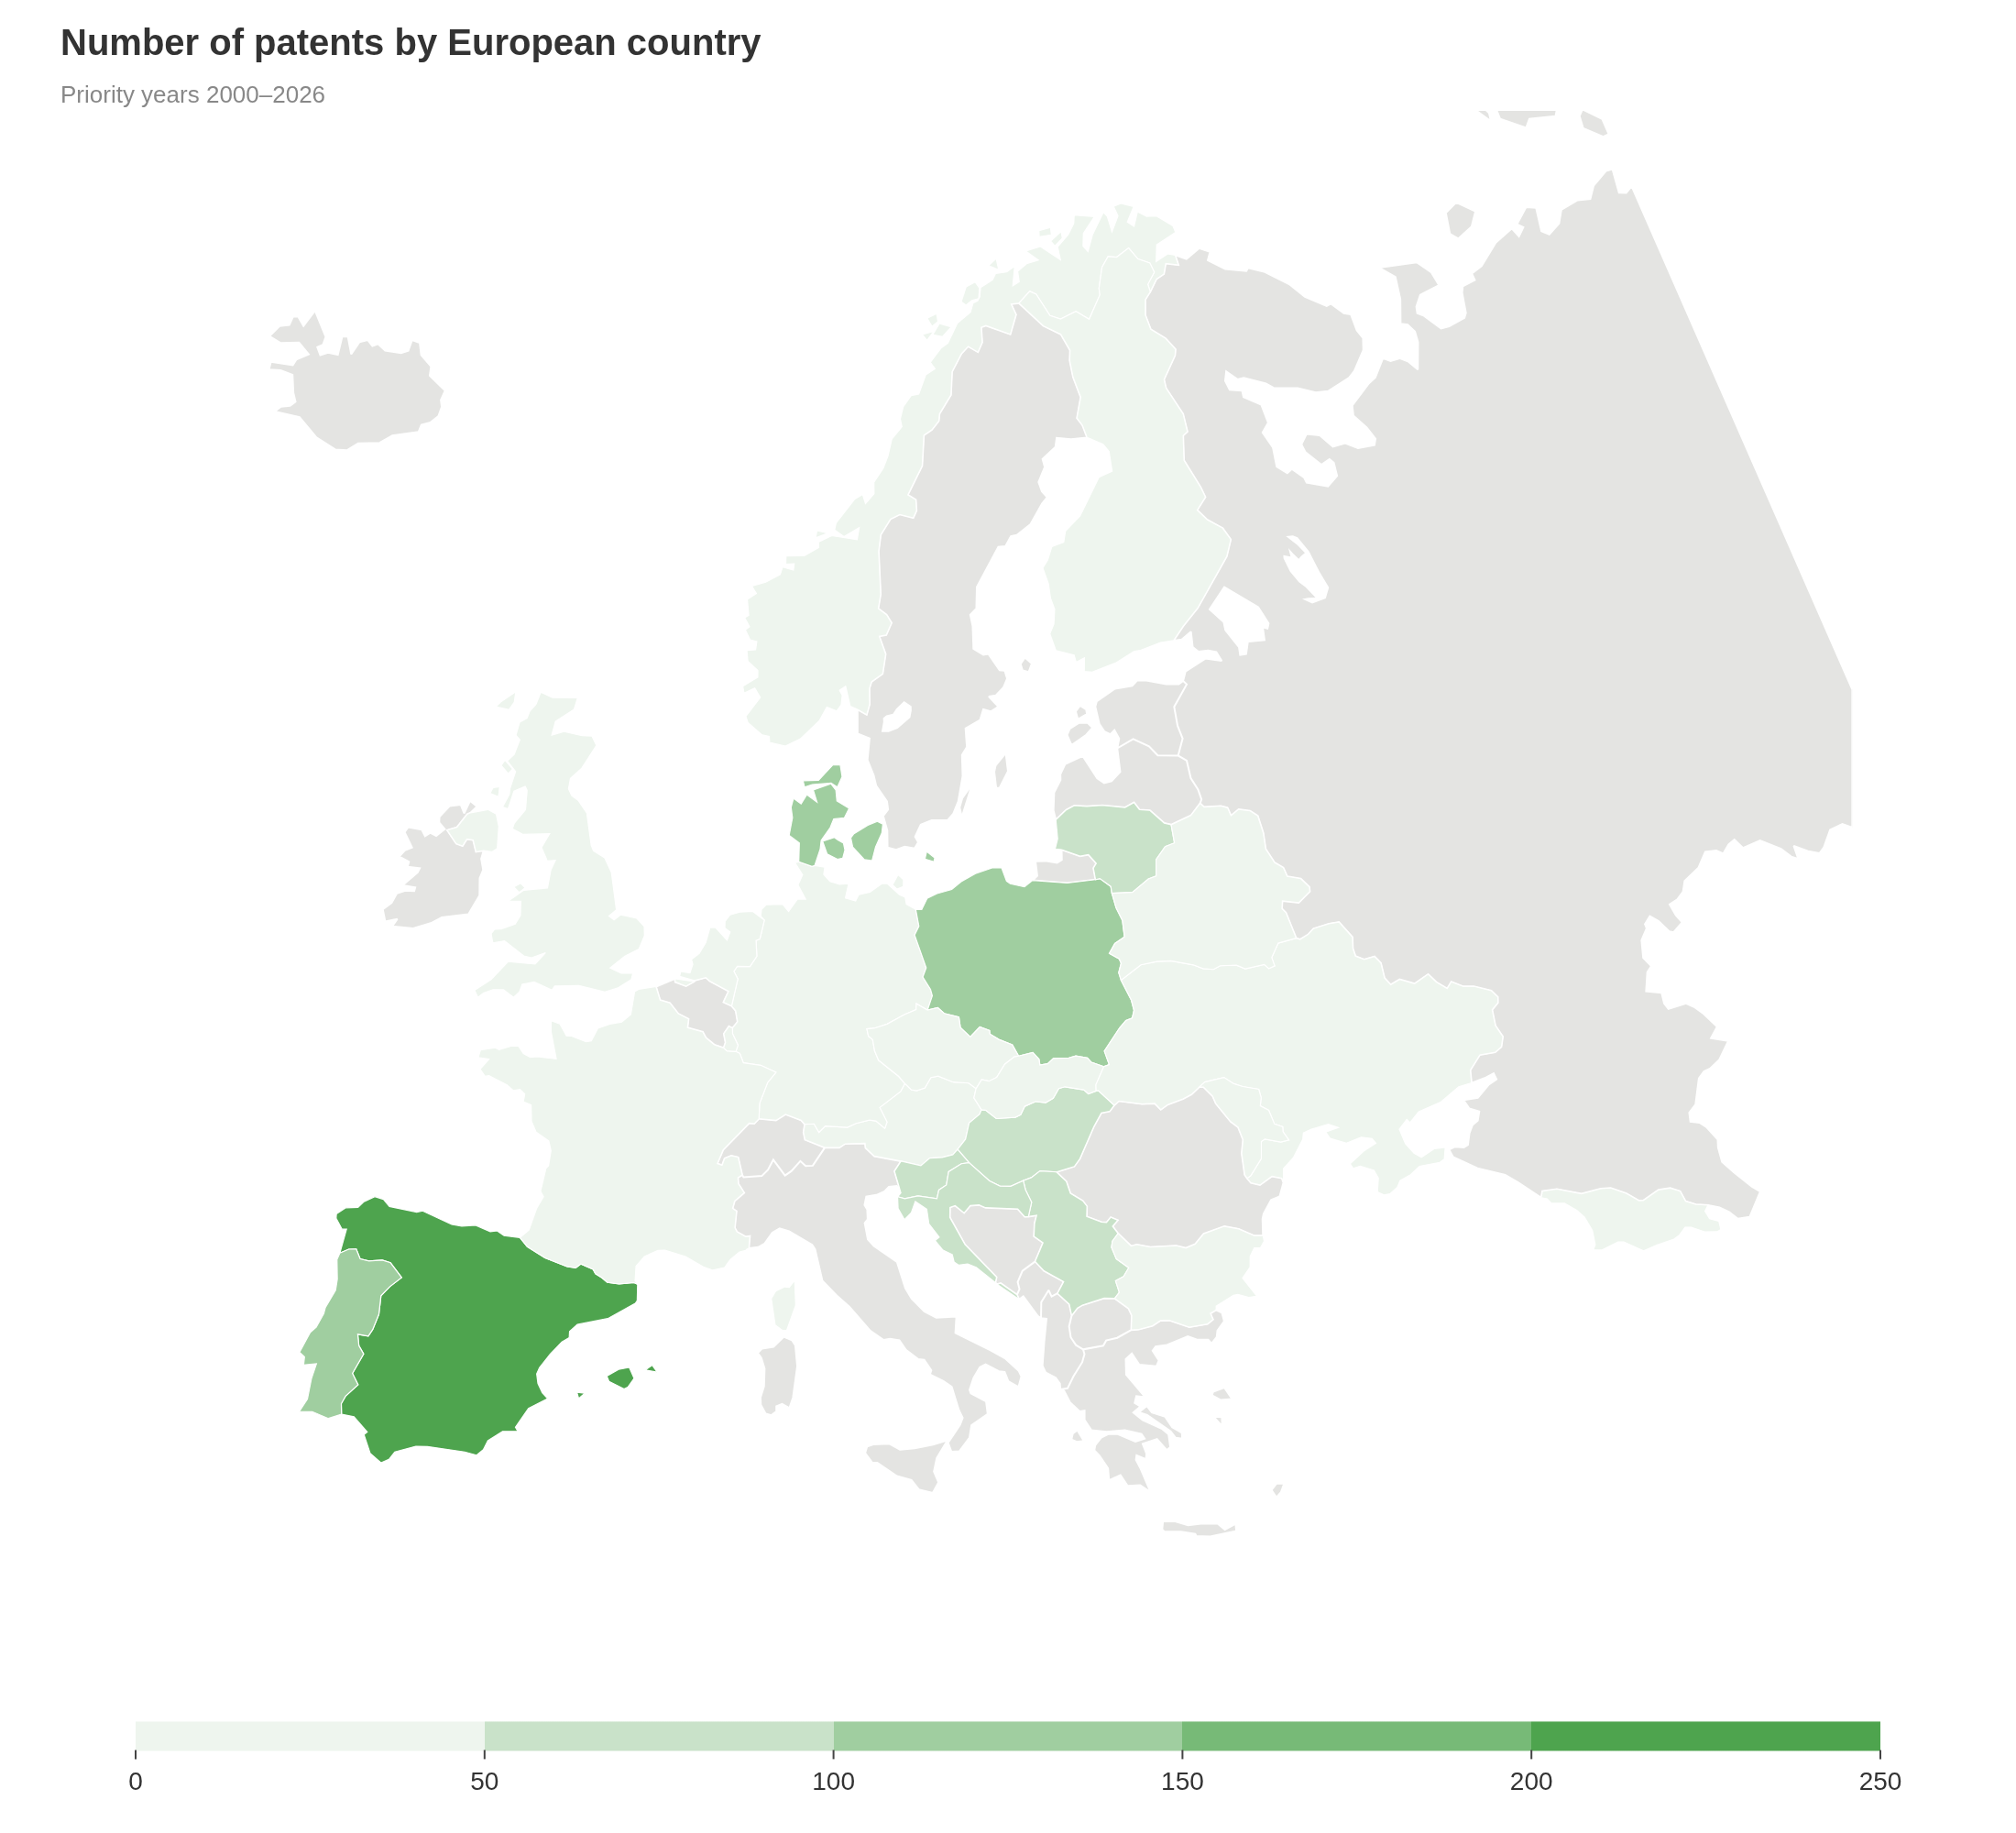
Figure 2 – Map of patent distributions in Europe.
Source: own elaboration with infogram.com application

4.2 Patents features
Table 2 presents, for each of the 12 compounds covered by the corrected Minesoft-based classification (see Methodology), the number of Spain-relevant patent families classified as Directly Relevant or Indirectly Relevant, superseding the earlier Espacenet-based patent counts for this table. Of the 872 unique Spain-relevant families identified across all 12 compounds, 157 were classified as substantively relevant (91 Directly Relevant, 66 Indirectly Relevant); the remainder were Incidental Mentions (712) or Uncertain (3). Table 2 reports 161 compound–family observations rather than 157 unique families because four families matched more than one compound's search and are counted once per compound they matched.

Table 2 – Total number of patents per compound
Compound | Directly Relevant | Indirectly Relevant | Total Relevant
Cytarabine | 69 | 54 | 123
Eribulin mesylate | 8 | 0 | 8
Brentuximab vedotin | 5 | 2 | 7
Trabectedin | 3 | 3 | 6
Vidarabine | 1 | 3 | 4
Polatuzumab vedotin | 4 | 0 | 4
Enfortumab vedotin | 2 | 2 | 4
Plitidepsin | 0 | 2 | 2
Omega 3 acid ethyl esters | 2 | 0 | 2
Ziconotide | 1 | 0 | 1
Omega 3 carboxylic acid | 0 | 0 | 0
Lurbinectedin | 0 | 0 | 0
Source: own elaboration.

In order to analyze the different compounds that generated each of the patents, according to their marine organism, a radial hierarchical diagram was generated as shown in Figure 3. Brentuximab vedotin, Polatuzumab vedotin, and Enfortumab vedotin share the same marine organism of origin, Mollusk/Cyanobacterium; under the corrected relevance classification (Table 2), Cytarabine is the leading compound by number of Spain-relevant patent families (123), followed by Eribulin mesylate (8) and Brentuximab vedotin (7).

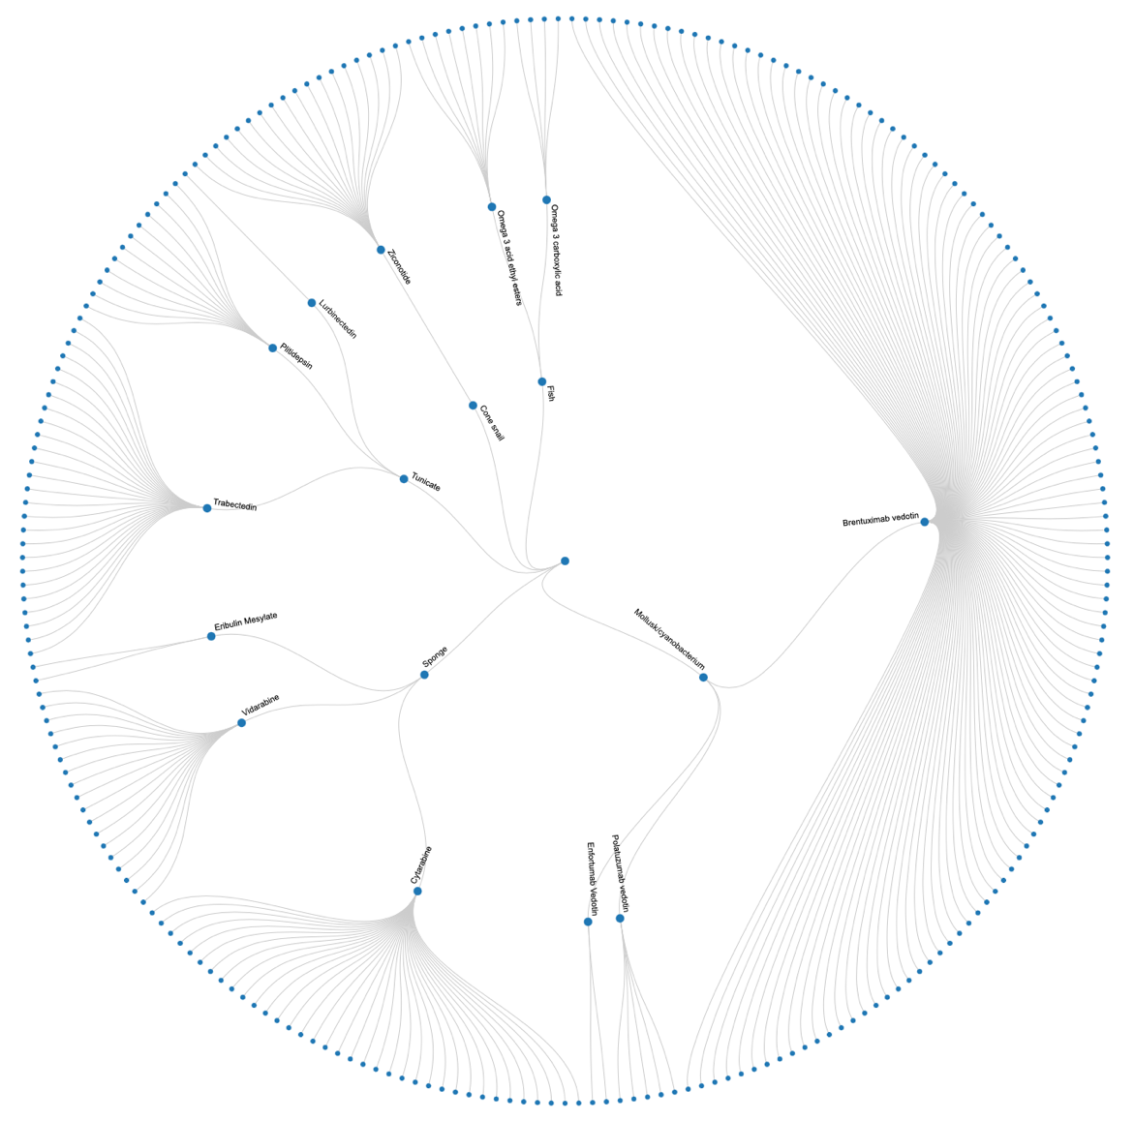
Figure 3 – Radial hierarchical diagram of patents according to compound and respective marine organism
Source: own elaboration with rawgraphs.io application

The Sponge marine organism originates three compounds in the analysis (Cytarabine, Vidarabine, and Eribulin mesylate); under the corrected classification, this group now accounts for the largest number of Spain-relevant patent families (135) of the five organism groups, ahead of Mollusk/Cyanobacterium (15). The Tunicate marine organism generates three compounds (Trabectedin, Plitidepsin, and Lurbinectedin), together accounting for 8 relevant families. The Cone snail is responsible for the Ziconotide-related patents (1 relevant family), and the fish-derived Omega-3 acid ethyl esters and Omega-3 carboxylic acid compounds together account for 2 relevant families.
Figure 4 presents the alluvial graph of the disease areas where the compounds are used. The three leading compounds by number of Spain-relevant patent families under the corrected classification are Cytarabine (123), Eribulin mesylate (8), and Brentuximab vedotin (7), all dedicated to cancer treatments. Cytarabine's large absolute count partly reflects its much larger screened universe (690 Spain-relevant families screened, a ≈17.8% relevance rate) compared to other compounds; Eribulin mesylate, by contrast, has a substantially higher relevance rate (8 of 18 screened, ≈44%), a distinction the raw family counts alone do not convey. Brentuximab vedotin is vastly used for Anaplastic large T-cell systemic malignant lymphoma and Hodgkin’s disease treatments, while Cytarabine is dedicated to Leukemia. Trabectedin is used for soft tissue sarcoma and ovarian cancer treatment. Ziconotide is implemented for severe chronic pain, while Vidarabine is used for Herpes simplex virus treatment. Plitidepsin is also used for cancer treatment (Multiple Myeloma, Leukemia, and Lymphoma), and the Hyperdriglyceridemia disease is treated with the two Omega 3 by-compounds (Acid Ethyl Esters, and Carboxylic Acid).
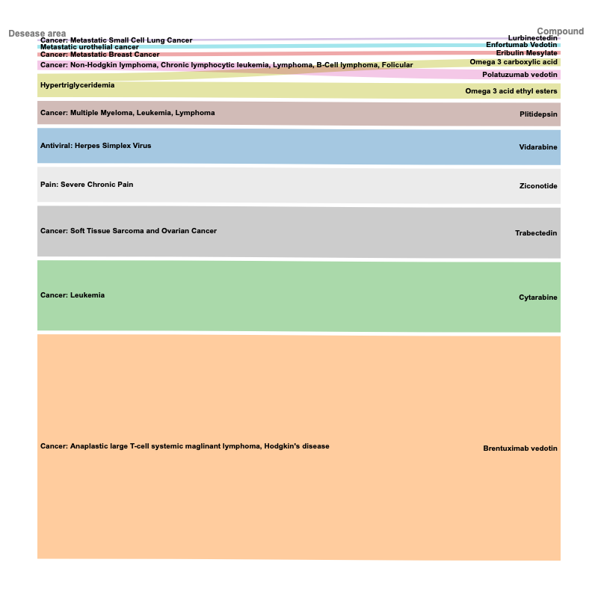
Figure 4 – Alluvial diagram of compounds and respective disease treatment
Source: own elaboration with rawgraphs.io application

Table 3 – Number of patents per Spanish region
Spanish region | n patents
Andalusia | 1
La Coruña | 2
Madrid | 14
Valencia | 1
Source: primary data.

Table 5 – Top 10 Spanish companies per number of patents owned
Solicitante homogeneizado | n patents
MERCK PATENT GMBH | 21
BAYER AG | 10
PHARMA MAR SA | 9
PFIZER | 8
CELLECTIS | 7
NOVARTIS AG | 7
4D PHARMA RES LTD | 6
ABBVIE BIOTHERAPEUTICS INC | 3
HOFFMANN LA ROCHE | 3
HUMMINGBIRD BIOSCIENCE HOLDINGS PTE LTD | 3

The results reveal that Madrid stands out as the leading region in Spain in terms of patent activity, with Pharma Mar S.A. as the main company in the country in terms of patent ownership. Looking at the Patent Search Reports for the patents in our study, 72% of the patents include an X (prior art of particular relevance) and 32% include a Y (prior art of special relevance when combined with other documents). In 26% of the patents, documents were found that were published between the priority date and the application date (category P). Finally, only 3% contain unpublished prior art as of the application date (category E).

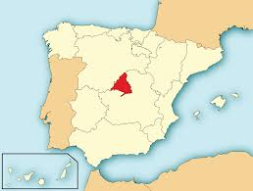
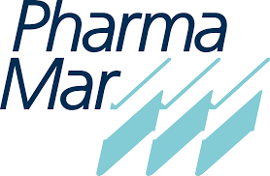

Figure 5 – Leading company location (Pharma Mar) and the patent analysis

4.2. Discussion
This study offers an in-depth examination of pharmaceutical innovation driven by marine bioprospecting, analyzed through the strategic lens of the Blue Economy. By focusing on patent activity related to approved marine-derived drugs, the findings expose both the sector's considerable potential and its current limitations.
At the national level, Spain’s patent activity is strongly concentrated in the Community of Madrid, with Pharma Mar S.A. leading as the primary patent holder. This centralization reflects the clustering of R&D infrastructure, financial capital, and institutional expertise. However, it also reveals regional imbalances in innovation capacity. As suggested by Raimundo et al. (2018), broadening scientific and technological capabilities across more autonomous communities would foster a more inclusive and territorially balanced Blue Economy. Regional diversification policies and knowledge transfer mechanisms could catalyze innovation ecosystems beyond Madrid and enable greater territorial cohesion in marine biotechnological development.
The internationalization of these patents—particularly through extensions into the United States, China, and Australia—demonstrates a deliberate strategy by Spanish firms to position themselves competitively in high-value global markets. These countries are not only leaders in pharmaceutical consumption but also in marine biotechnology innovation, reinforcing the importance of transnational cooperation (Blasiak et al., 2018). Nonetheless, the concentration of patent ownership in a handful of high-income countries raises concerns regarding global asymmetries in access to marine genetic resources and the equitable sharing of benefits (Arnaud-Haond et al., 2011).
The biological origins of patented compounds show a notable dependence on a few well-known marine organisms: mollusks/cyanobacteria, sponges, tunicates, cone snails, and fish. This pattern may indicate a risk-averse approach by firms that prioritize compounds with a more predictable path to regulatory approval and commercialization (Pereira & Costa-Lotufo, 2017; Smith et al., 2019). While such strategies can enhance efficiency, they may also limit the exploration of lesser-known organisms with significant pharmacological potential. This underscores the need for sustained public investment in basic marine research to broaden the scope of discovery and reduce over-reliance on a narrow biological base (Anestopoulos et al., 2020).
Patent Search Reports (PSRs) further illuminate the dynamics of innovation in this field. The high incidence of X-category documents (72%) highlights that many patented inventions are closely linked to existing prior art. The presence of Y-category references in 32% of patents indicates that, while individually not novel, combinations of known elements could affect the inventive step, creating potential legal and commercial uncertainties. Additionally, 26% of patents include P-category references, reflecting the time-sensitive nature of patenting and the rapid pace of new knowledge production. Although only 3% of patents included unpublished prior art (E-category), this still reflects the complexity of navigating dynamic and evolving research landscapes (Hunt & Vincent, 2006).
These patterns collectively suggest that marine pharmaceutical innovation operates within a sophisticated yet vulnerable system—dominated by a few institutions and based on a limited set of organisms. While companies such as Pharma Mar S.A. represent successful cases of translating marine bioprospecting into marketable drugs, the broader innovation system may lack the resilience, equity, and diversification necessary for long-term sustainability (Cisneros-Montemayor et al., 2021; Keen et al., 2017).
Policy interventions are therefore crucial. Strengthening legal and institutional frameworks for benefit-sharing, particularly in Areas Beyond National Jurisdiction (UNCLOS, 1982), would enhance fairness and legitimacy in the exploitation of marine genetic resources. The establishment of clearer guidelines—such as those promoted by the Nagoya Protocol (UN, 2010) and recent initiatives from the World Intellectual Property Organization (WIPO, 2024)—can help ensure that innovation in marine bioprospecting contributes to social inclusion, environmental responsibility, and economic viability. Encouraging inter-institutional cooperation, both within and across countries, may also bridge gaps in capacity, governance, and access to technology (Silva, 2024).
As the UN Decade of Ocean Science progresses, aligning pharmaceutical innovation with the guiding principles of the Blue Economy will be essential. Ensuring that marine-based drug development fosters environmental sustainability, global equity, and economic inclusiveness remains a critical and ongoing challenge.

5. Conclusion
This study aimed to explore the dynamics of pharmaceutical innovation rooted in marine bioprospecting, using Spain as a case study and applying a patent-based analytical approach within the broader framework of the Blue Economy. By focusing on approved marine-derived drugs and associated patent activity, the research provides novel empirical insights into the geographic concentration, biological sources, and legal characteristics of innovation in this emerging sector.
Our findings highlight that marine pharmaceutical innovation in Spain is highly centralized in the Community of Madrid, largely driven by the activities of Pharma Mar S.A. While this reflects strong institutional capacity and targeted investment, it also underscores the uneven distribution of innovation potential across autonomous communities. Such centralization may hinder inclusive regional development and calls for policy interventions to support knowledge diffusion and R&D capabilities beyond major urban hubs.
Internationally, the concentration of patent extensions in high-income countries such as the United States, China, and Australia reveals a strategic focus on protecting intellectual property in global markets. However, this also brings to light persistent geopolitical asymmetries in access to and benefit-sharing from marine genetic resources. From a governance perspective, these findings reinforce the need for clearer legal mechanisms and multilateral cooperation frameworks to ensure equity, particularly for countries with limited technological infrastructure.
The analysis of biological sources confirms a reliance on a narrow pool of marine organisms—molluscs/cyanobacteria, sponges, tunicates, cone snails, and fish—suggesting a risk-averse innovation strategy. While commercially logical, this limits biodiversity-based innovation and underutilizes the broader potential of marine ecosystems. The data further show that most patented inventions are built on well-established prior art (as revealed by the high presence of X and Y category documents in Patent Search Reports), indicating incremental rather than radical innovation trends. Additionally, the temporal dynamics of P-category documents stress the importance of timing in the patenting process.
Despite offering a comprehensive overview, the study is not without limitations. The scope was restricted to patents associated with already-approved marine-derived drugs, potentially excluding emerging compounds still in the research pipeline. Moreover, while the analysis offers strong descriptive insights, it does not include in-depth interviews or fieldwork with R&D actors, which could provide richer qualitative perspectives on innovation processes.
Future research could expand the scope to other countries involved in marine biotechnology, explore unapproved compounds in clinical trials, or integrate social network analysis to map collaborative innovation ecosystems. Qualitative studies involving public research institutions, pharmaceutical firms, and marine biologists could also yield deeper insights into institutional dynamics, innovation bottlenecks, and regulatory frameworks.
For practitioners and policymakers, the results highlight the importance of fostering decentralized innovation ecosystems, supporting early-stage marine research, and reinforcing fair and transparent benefit-sharing mechanisms. Strategic investment in underexplored marine organisms, especially through public–private partnerships, could unlock new therapeutic solutions while ensuring alignment with the sustainability goals of the Blue Economy.
As we advance through the United Nations Decade of Ocean Science for Sustainable Development, aligning marine pharmaceutical innovation with the principles of environmental responsibility, economic viability, and global equity remains both a challenge and an opportunity.

References
Anestopoulos, I., Kiousi, D. E., Tzatzarakis, M. N., Tsatsakis, A. M., Franco, R., & Tsoukalas, D. (2020). Marine-derived surface active agents: Health-promoting properties and blue biotechnology-based applications. Biomolecules, 10(6), 885. https://doi.org/10.3390/biom10060885
Arnaud-Haond, S., Arrieta, J. M., & Duarte, C. M. (2011). Global genetic resources: Marine biodiversity and gene patents. Science, 331(6024), 1521–1522. https://doi.org/10.1126/science.1200783
Bilbao, J., Madariaga, I., Mendiola, D., & Revilla, M. (2020). Suitability of two areas of the Basque coast to sustain shellfish aquaculture according to both the presence of potentially toxic phytoplankton and the biotoxins regulated by the European Union. Regional Studies in Marine Science, 36, 101308. http://doi.org/10.1016/j.rsma.2020.101279
Bjørkan, M., & Eilertsen, S. (2020). Local perceptions of aquaculture: A case study on legitimacy from northern Norway. Ocean and Coastal Management, 195, 105251. https://doi.org/10.1016/j.ocecoaman.2020.105276
Blasiak, R., Jouffray, J.-B., Wabnitz, C. C. C., Sundström, E., & Österblom, H. (2018). Corporate control and global governance of marine genetic resources. Science Advances, 4(6), eaar5237. https://doi.org/10.1126/sciadv.aar5237
Boonstra, W. J., Valman, M., & Björkvik, E. (2018). A sea of many colours – How relevant is Blue Growth for capture fisheries in the Global North, and vice versa? Marine Policy, 87, 340–349. https://doi.org/10.1016/j.marpol.2017.09.007
Bruno, F., Lagudi, A., Muzzupappa, M., & Cozza, M. (2020). Digital technologies for the sustainable development of the accessible underwater cultural heritage sites. Journal of Marine Science and Engineering, 8(12), 955. https://doi.org/10.3390/jmse8110955
Cisneros-Montemayor, A. M., Moreno-Báez, M., Ota, Y., Meng, K., & Cisneros-Mata, M. A. (2019). Social equity and benefits as the nexus of a transformative Blue Economy: A sectoral review of implications. Marine Policy, 109, 103702. https://doi.org/10.1016/j.marpol.2019.103702
Cisneros-Montemayor, A. M., Virdin, J., Ventresca, D., et al. (2021). Enabling conditions for an equitable and sustainable Blue Economy. Nature, 591(7850), 396–401. https://doi.org/10.1038/s41586-021-03327-3
Contreras, C., & Thomas, S. (2019). The role of local knowledge in the governance of blue carbon. Journal of the Indian Ocean Region, 15(2), 213–234. https://doi.org/10.1080/19480881.2019.1610546
DiMasi, J. A., Grabowski, H. G., & Hansen, R. W. (2016). Innovation in the pharmaceutical industry: New estimates of R&D costs. Journal of Health Economics, 47, 20–33. https://doi.org/10.1016/j.jhealeco.2016.01.012
Drius, M., Portioli, M., Depellegrin, D., et al. (2019). Tackling challenges for Mediterranean sustainable coastal tourism: An ecosystem service perspective. Science of the Total Environment, 652, 1302–1317. https://doi.org/10.1016/j.scitotenv.2018.10.121
Ferasso, M., Bares, L., Ogachi, D., & Blanco, M. (2021). Economic and Sustainability Inequalities and Water Consumption of European Union Countries. Water, 13(19), 2696. https://doi.org/10.3390/w13192696
Ferasso, M., Bares, L., Ogachi, D., & Blanco, M. (2021). Economic and Sustainability Inequalities and Water Consumption of European Union Countries. Water, 13(19), 2696. https://doi.org/10.3390/w13192696
Harper, S., Adshade, M., Lam, V. W. Y., Pauly, D., & Sumaila, U. R. (2020). Valuing invisible catches: Estimating the global contribution by women to small-scale marine capture fisheries production. PLoS ONE, 15(3) https://doi.org/10.1371/journal.pone.0228912
Howard, B. C., Silver, J. J., & Gray, N. J. (2018). Blue growth: Stakeholder perspectives. Marine Policy, 87, 375–377. https://doi.org/10.1016/j.marpol.2017.11.002
Hunt, B., & Vincent, A. C. J. (2006). Scale and sustainability of marine bioprospecting for pharmaceuticals. AMBIO: A Journal of the Human Environment, 35(2), 57–64. https://doi.org/10.1579/0044-7447
Kalogirakis, N., Fatta-Kassinos, D., Vasquez, M. I., & Frontistis, Z. (2015). The role of environmental biotechnology in exploring, exploiting, monitoring, preserving, protecting and decontaminating the marine environment. New Biotechnology, 32(1), 157–167. https://doi.org/10.1016/j.nbt.2014.03.007
Keen, M. R., Schwarz, A.-M., & Wini-Simeon, L. (2018). Towards defining the Blue Economy: Practical lessons from Pacific Ocean governance. Marine Policy, 88, 333–341. https://doi.org/10.1016/j.marpol.2017.03.002
Kildow, J. T., & McIlgorm, A. (2010). The importance of estimating the contribution of the oceans to national economies. Marine Policy, 34(3), 367–374. https://doi.org/10.1016/j.marpol.2009.08.006
Lavidas, G., De Leo, F., & Besio, G. (2020). Blue growth development in the Mediterranean Sea: Quantifying the benefits of an integrated wave energy converter at Genoa harbour. Energies, 13(3), 589. https://doi.org/10.3390/en13164201
Lee, K. H., Noh, J., & Khim, J. S. (2020). The Blue Economy and the United Nations’ Sustainable Development Goals: Challenges and opportunities. Environment International, 137, 105528. https://doi.org/10.1016/j.envint.2020.105528
Michel, J. A. (2016). Rethinking the oceans: Towards the Blue Economy. Paragon House.
Morrissey, K. (2017). It’s not just a Blue Economy moment…. Dialogues in Human Geography, 7(1), 42–44. https://doi.org/10.1177/2043820617691651
Mulazzani, L., & Malorgio, G. (2017). Blue growth and ecosystems services. Marine Policy, 85, 17–24. https://dx.doi.org/10.1016/j.marpol.2017.08.006
Ocean & Coastal Management, 157, 180–192. https://doi.org/10.1016/j.ocecoaman.2018.03.001
Organisation for Economic Cooperation and Development. (2016). The ocean economy in 2030. OECD Publishing.
Otero, R. M. F., Bayliss-Brown, G. A., & Papathanassiou, M. O. (2019). Literacy and knowledge transfer synergies in support of a sustainable blue economy. Frontiers in Marine Science, 6, 646. https://doi.org/10.3389/fmars.2019.00646
Outeiro, L., Villasante, S., & Alonso, M. (2020). Influence of aquaculture on fishing strategies: Insights from Galician small-scale fisheries. Aquaculture, 521, 735019. https://doi.org/10.1016/j.aquaculture.2020.735043
Pereira, R. C., & Costa-Lotufo, L. V. (2012). Bioprospecting for bioactives from seaweeds: Potential, obstacles and alternatives. Revista Brasileira de Farmacognosia, 22(4), 894–905. https://doi.org/10.1590/S0102-695X2012005000077
Pinto, H., Cruz, A. R., & Combe, C. (2015). Cooperation and the emergence of maritime clusters in the Atlantic: Analysis and implications of innovation and human capital for the blue growth. Marine Policy, 57, 167–177. https://doi.org/10.1016/j.marpol.2015.03.029
Raimundo, I., Silva, S. G., Costa, R., et al. (2018). Bioactive secondary metabolites from octocoral-associated microbes—New chances for blue growth. Marine Drugs, 16(12), 485. https://doi.org/10.3390/md16120485
Rusyaev, S. M., & Orlov, A. M. (2024). The phenomenon of marine bioprospecting. Biology Bulletin Reviews, 14(1), 115–132. https://doi.org/10.1134/S2079086424010080
Sarker, S., Bhuyan, M. A. H., & Iftekhar, M. S. (2018). From science to action: Exploring the potentials of Blue Economy for enhancing economic sustainability in Bangladesh.
Schmidt-Traub, G., Kroll, C., Teksoz, K., Durand-Delacre, D., & Sachs, J. D. (2017). National baselines for the Sustainable Development Goals assessed in the SDG Index and Dashboards. Nature Geoscience, 10(8), 547–555. https://doi.org/10.1038/ngeo2985
Sheng, W., & Lewis, A. (2016). Wave energy conversion of oscillating water column devices including air compressibility. Journal of Renewable and Sustainable Energy, 8(5), 054501. https://doi.org/10.1063/1.4962922
Silver, J. J., Gray, N. J., Campbell, L. M., Fairbanks, L. W., & Gruby, R. L. (2015). Blue economy and competing discourses in international oceans governance. Journal of Environment & Development, 24(2), 135–160. https://doi.org/10.1177/1070496515580797
Smith-Godfrey, S. (2016). Defining the Blue Economy. Maritime Affairs: Journal of the National Maritime Foundation of India. https://doi.org/10.1080/09733159.2016.1175131
Smith, D., Harrison, J. P., & Sims, I. M. (2019). Discovery pipelines for marine resources: An ocean of opportunity for biotechnology? World Journal of Microbiology and Biotechnology, 35(7), 107. https://doi.org/10.1007/s11274-019-2685-y
Tollefson, J., & Gilbert, N. (2012). Earth summit: Rio report card. Nature, 486(7401), 20–23. https://doi.org/10.1038/486020a
United Nations Convention on the Law of the Sea. (1982). United Nations Convention on the Law of the Sea.
United Nations. (2015). Transforming our world: The 2030 Agenda for Sustainable Development. https://sdgs.un.org/2030agenda
Upadhyay, D. K., & Mishra, M. (2020). Blue economy: Emerging global trends and India’s multilateral cooperation. Maritime Affairs: Journal of the National Maritime Foundation of India, 16(1), 30–45. https://doi.org/10.1080/09733159.2020.1785087
Vedachalam, N., Ravindran, M., & Atmanand, M. A. (2019). Technology developments for the strategic Indian Blue Economy. Marine Georesources & Geotechnology, 37(7), 828–844. https://doi.org/10.1080/1064119X.2018.1501625
Vierros, M., Suttle, C. A., Harden-Davies, H., & Burton, G. (2016). Who owns the ocean? Policy issues surrounding marine genetic resources. Limnology and Oceanography Bulletin, 25(1), 29–35. https://doi.org/10.1002/lob.10108
Voyer, M., Quirk, G., McIlgorm, A., & Azmi, K. (2018). Shades of blue: What do competing interpretations of the Blue Economy mean for oceans governance? Journal of Environmental Policy & Planning, 20(5), 595–616. https://doi.org/10.1080/1523908X.2018.1473153
Voyer, M., van Leeuwen, J. (2019). ‘Social license to operate’ in the Blue Economy. Resources Policy, 62, 102–113. https://doi.org/10.1016/j.resourpol.2019.02.020
Wang, L.-L., & Xiao, W.-W. (2017). Interactive development relationship between technological innovation and blue economy – A case study of Shandong Province. Journal of Interdisciplinary Mathematics, 20(6–7), 1449–1453. https://doi.org/10.1080/09720502.2017.1382155
Winder, G. M., & Le Heron, R. (2017). Assembling a Blue Economy moment? Geographic engagement with globalizing biological-economic relations in multi-use marine environments. Dialogues in Human Geography, 7(1), 3–26.
https://doi.org/10.1177/20438206176916
WIPO. (2024). World Intellectual Property Report 2024: Making innovation policy work for development. Geneva: World Intellectual Property Organization.
World Wide Fund for Nature. (2015). Reviving the ocean economy: The case for action. Gland: WWF. https://c402277.ssl.cf1.rackcdn.com/publications/790/files/original/Reviving_Ocean_Economy_REPORT_low_res.pdf?1429717323
Wright, G. (2016). Regulating wave and tidal energy: An industry perspective on the Scottish marine governance framework. Marine Policy, 65, 115–126. https://doi.org/10.1016/j.marpol.2015.12.014

